Probability of Error when comparing dense vectors with different library sizes

The probability, $P_{hd}(m) ,$of measuring a hamming distance hd when an unbound vector from a bundled vector of size m is compared to a single random vector is computed as follows:

The mean normalised hamming distance is given by:

$$μ_{hd}(m)=1-\left(1- \frac{1}{2^{m}} × \sum_{i=m/2}^{m}{comb\left(\frac{m}{i}\right)}\right)$$

The mean normalised hamming distance between two random vectors is 0.5.

Then the probability distribution for matching the unbound vector with a random vector is a binomial distribution given by:

$$P_{hd}=binom\left(hd,B,μ_{hd}(m)\right)$$

Where binom is the probability mass function.

Similarly, the probability distribution for matching any two random vectors is also a binomial distribution given by:
$$P_{n}=binom\left(hd,B,0.5\right)$$

We now want to compute the probability of correctly matching with a ‘clean’ version of itself when comparing the unbound vector with a library of M random vectors plus a clean version of itself.

The probability of not matching with any noise vector in a library of size M is given by:

$$P_{M}{= \left(1-cum(hd,B,0.5)\right)}^{M}$$

Where $cum\left( \right) is the cumulative binomial distribution function.$Hence the probability of matching the unbound vector with the clean vector and not a noise vector is given by:

$$P_{match}{= P}_{hd}× P_{M}$$

The expected distribution for the number of matches after T trials is given by:

$HD0_{all}=$INT$\left(P_{hd} × T\right)$
And the expected number of correct matches, which we call wins is given by:

$$all_{wins}= {INT(P}_{match} × T)$$

The expected total number of matches is then given by:

$$E_{hd(match)}= \sum_{hd=0}^{+∞}{all_wins}$$

Here are some results for 100 and 10,00 noise vectors showing the measured and predicted results. HD0 refers to the expected number of matches between the bound vector and noise and the expected number of wins at each hamming distance.

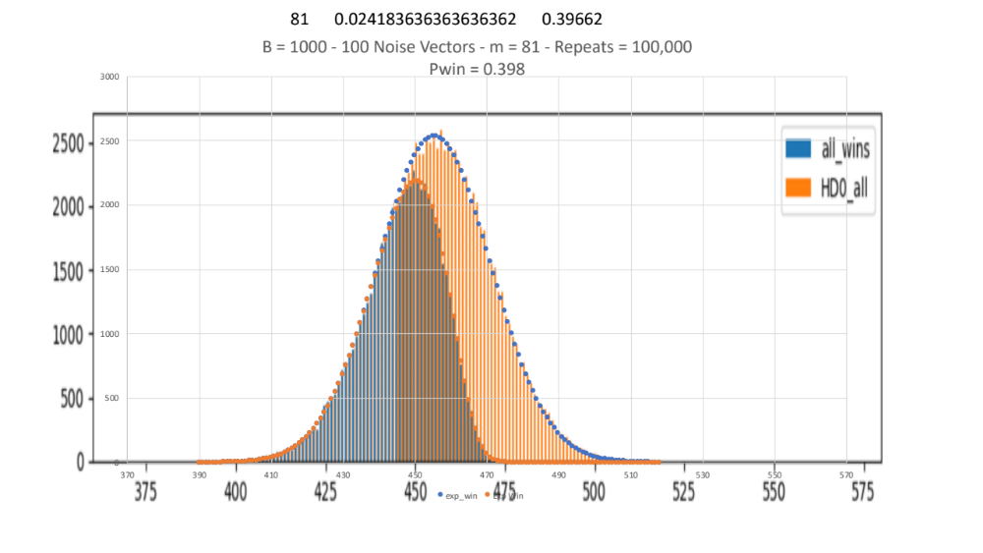
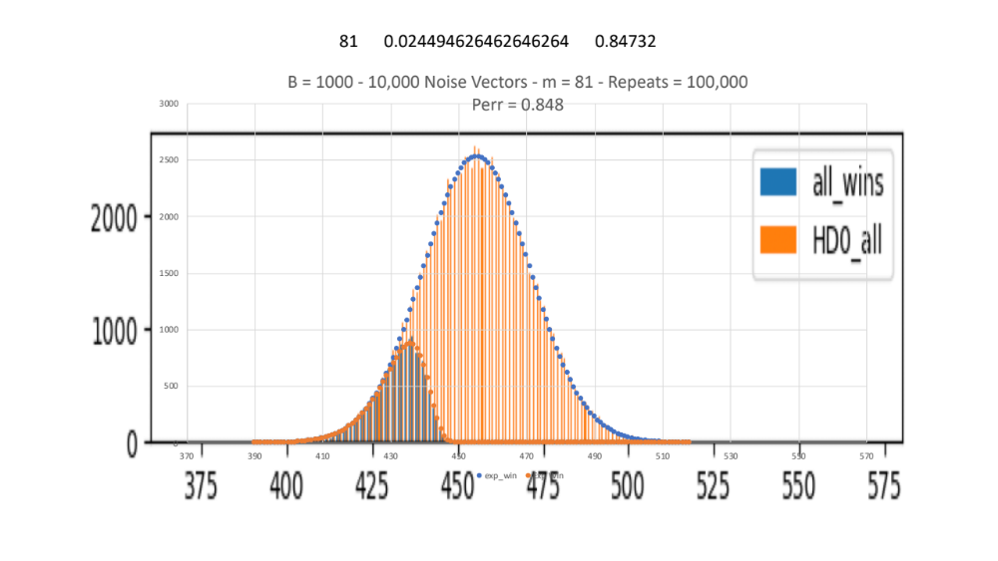

Below are some results for the predicted error as a function of the number of vectors in the chunk. I have plotted as probability of error which is obviously

$P_{win}= \frac{\left({1-E}_{hd(match}\right)}{T}$

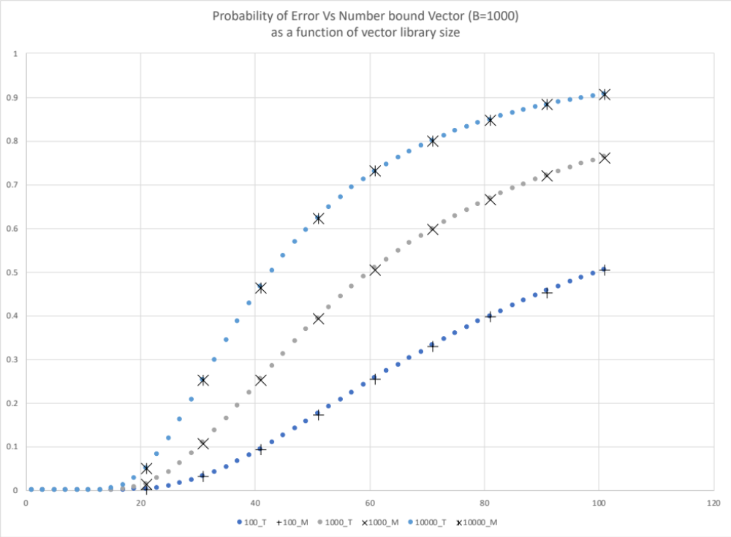

Code for the theory is Pred_Error vs m_v2.py

import scipy.misc as sc
import math
import numpy as np
from scipy.stats import binom

# This code computes the expected error in decoding m superposed vectors

max_m = 21
B=2048

M = 500 #Library size
T = 100000 # repeat trials

print("Vector size=",B, "library size=", M)

for i in range (1,max_m+2,2):
HD0_all=[]
all_wins=[]
P=0
k=i-1
for j in range (int(k/2),k+1):
P = P + sc.comb(k,j)
hd = 1.0-P/2**(k)

for j in range(0,B):
P_hd = binom.pmf(j,B,hd)
P_n = binom.pmf(j,B,0.5)
P_M= (1 - binom.cdf(j,B,0.5))**M
P_match = P_hd*P_M
HD0_all.append(int(P_hd * T))
all_wins.append(int(P_match*T))
P_win = sum(all_wins)/T
P_error = 1-P_win
print(P_error)

Code for measurement is Test_Dense_Prob_All_m_bind_3.py

import numpy as np
import vsapy as vsa
import random
import timeit
import math
from scipy.stats import poisson
from scipy.stats import expon
#from vectors import normalize
import matplotlib.pyplot as plt

def hamming(X,Y):
#This function computes the hamming distance between two binary vectors each of length n
h = np.sum(np.logical_xor(X,Y)*1.0)/n

return h;

def normalizeVector(V,seqLength):
if seqLength%2 == 0:
V = V + np.array([random.randint(0,1) for _ in range (n)])
seqLength = seqLength +1

for j in range(0,n):
if V[j] > seqLength/2:
V[j] = 1
else:
V[j] = 0
return V

n = 1000
Min_M = 21
Max_M = 51
M_Step = 10
Max_repeats = 100000
Num_Noise = 1000
Num_Compare = 1

#Noise_Vecs = vsa.randvec((Num_Noise,n))
print("Num_bits=",n,Min_M,Max_M,M_Step,Max_repeats,Num_Noise)

for Num_Sum in range(Min_M,Max_M+1,M_Step):
error_cnt = 0
error_cnt_1 = 0
P_error_sum = 0
P_error_sum=[]
P_error_all =[]
HD0_all=[]
hd_all = []
all_errors = []
all_wins=[]
all_draws=[]
Noise_Vecs = vsa.randvec((Num_Noise,n))
for repeats in range(0,Max_repeats):

# Generate Num_Sum role and filler vectors
Role_Vecs = vsa.randvec((Num_Sum,n)) # role vectors
Filler_Vecs = vsa.randvec((Num_Sum,n)) # filler vectors
Bound_Role_Filler = np.logical_xor(Role_Vecs,Filler_Vecs)
Zc = np.sum(Bound_Role_Filler,axis=0)
Zc = normalizeVector(Zc,Num_Sum)

# Now unbind Zc using unbind operator
P_err=[0]
# HD0=[]
win_cnt = 0
for j in range(0,Num_Compare):
Noise_Vecs[0] = Filler_Vecs[j]
Zuf = np.logical_xor(Role_Vecs[j],Zc)*1
hd = np.sum(np.logical_xor(Noise_Vecs,Zuf),axis=1)
# hd_all = np.concatenate((hd_all,hd))
# HD0.append(hd[0])
# HD0_all.append(hd[0])
Error_Values = hd[hd<=hd[0]]
N_err = len(Error_Values)
if N_err ==1:
win_cnt +=1
# P_error_all.append(0)
# all_wins.append(hd[0])
elif np.argmin(Error_Values) == hd[0]:
R = random.randint(0,N_err-1)
if R ==0:
error_cnt += 0
P_err.append(0)
# P_error_all.append(0)
# all_wins.append[hd[0]]
else:
# error_cnt += N_err-1
P_err.append(N_err-1)
# P_error_all.append(N_err-1)
# all_errors.append(hd[0])

else:
error_cnt += N_err-1
P_err.append(N_err-1)
# P_error_all.append(N_err-1)
# all_errors.append(hd[0])
# print(P_error)

# HD0_mean = np.mean(HD0)
# HD0_var = np.var(HD0)

if np.sum(P_err) > 0:
P_error_sum.append(1)
else:
P_error_sum.append(0)

Pm = np.mean(P_error_sum) # measured prob err when decoding against all vectors
P = error_cnt/((Num_Noise-1)*Max_repeats*Num_Compare) # measured prob of error per vector
print(Num_Sum," ", P," ", Pm)

Sparse Vector Binding

Firstly, need to use Patterns 6_1.py to obtain the equivalent hamming distance. The results are shown here with the code below for 256 slots and different sizes of bits:

from __future__ import generators
import numpy as np
import math
from scipy.special import factorial
from scipy.misc import comb
from scipy.special import perm

def calc_prob(elements,counts,B,D):
E = np.array(elements)
C = np.array(counts)
l = len(C) - 1
EC = E*C
Pn = num_patterns(E,C)
if D == 0:
C[l] -= 1
W = 1
else:
C[l-1] -= 1
W = counts[l] + 1
An = num_arrangements(C)
Rn = num_repeats(B,C)
P = Pn*An*Rn/(W * np.float_power(B,m-1))

return P

def num_patterns(E,C):
F = factorial(E)
Fp = np.power(F,C)
Pn = factorial(m-1)/np.product(Fp)
return Pn

def num_arrangements(C):
F = factorial(C)
An = factorial(sum(C))/np.product(F)
return An

def num_repeats(B,C):
Rn = comb(B-1,sum(C))
return Rn

def accel_asc(n):
a = [0 for i in range(n + 1)]
k = 1
y = n - 1
while k != 0:
x = a[k - 1] + 1
k -= 1
while 2 * x <= y:
a[k] = x
y -= x
k += 1
l = k + 1
while x <= y:
a[k] = x
a[l] = y
yield a[:k + 2]
x += 1
y -= 1
a[k] = x + y
y = x + y - 1
yield a[:k + 1]

def get_result(m,B,M):
cnt=0
p_cnt=0
w_cnt=0
d_cnt=0
P_sum = 0
T = 1.0
for value in accel_asc(m-1):
a = np.array(value)[::-1]
if len(a) <=B:
p_cnt +=1
elements, counts = np.asarray(np.unique(a,return_counts=True))
E = [0]
C = [0]
for i in range(0,len(elements)):
E.append(elements[i])
C.append(counts[i])
D = 0
P = calc_prob(E,C,B,D)
P_sum += P
w_cnt += 1
if P>=T:
print (a,P,P_sum,'W')

#If can be shared win divide by i_a
l = len(E) - 1
if l>=1 and E[l] - E[l-1] ==1:
p_cnt += 1
D = 1
if E[l] == 1:
C[0] = 1
P = calc_prob(E,C,B,D)
P_sum += P
d_cnt += 1
if P>=T:
print (a,P,P_sum,'D')
print(m,P_sum*M)
'''
print(m,B,M,'sum=',P_sum,P_sum*M)
print('Pattern Count=',p_cnt)
print('win count=',w_cnt)
print('draw_cnt=', d_cnt)
'''

B = 32
M = 200
print("Num_slots=",M,"Num_bits=",B)
for m in range(1,21,2):
get_result(m,B,M)

Using same theory as for dense vectors we can compute the probability of error and get following results. (See Sparse Vector Results2 .xslx for theory and use Test_Sparse_Prob_All_m_bind_2.1.py to produce measured results.

Here are some example haming distance predictions and measurements:

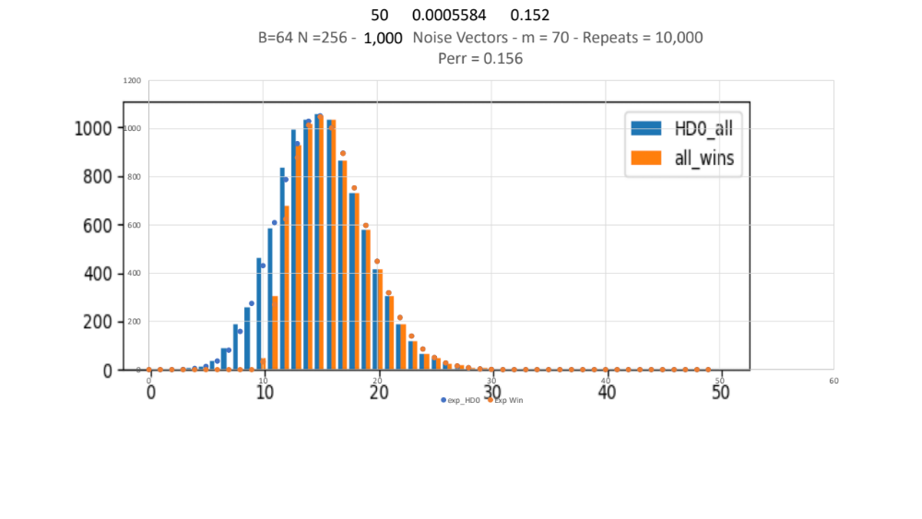

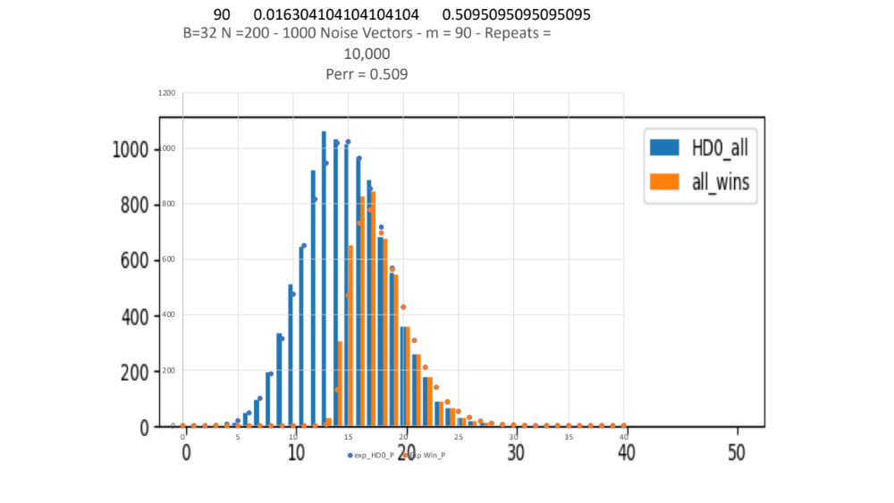

And here are some comparisons with dense vectors which shows that the equivalent sparse vector for a 1000 bit dense vector is more like 32bit-150 slots than the anticipated 32bit-200 slots.

There is some evidence from the theory that this situation reverses for lower numbers of bound vectors.

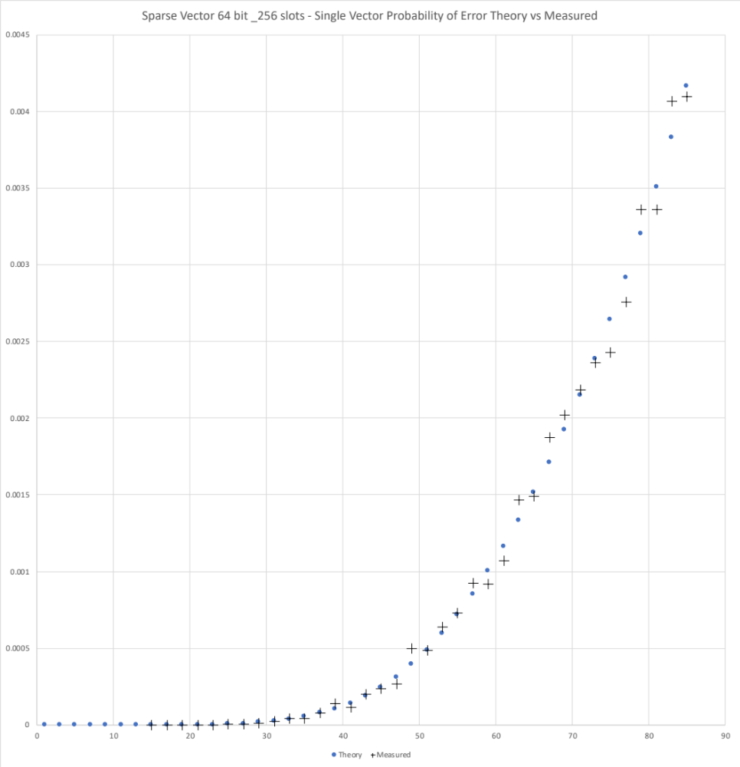

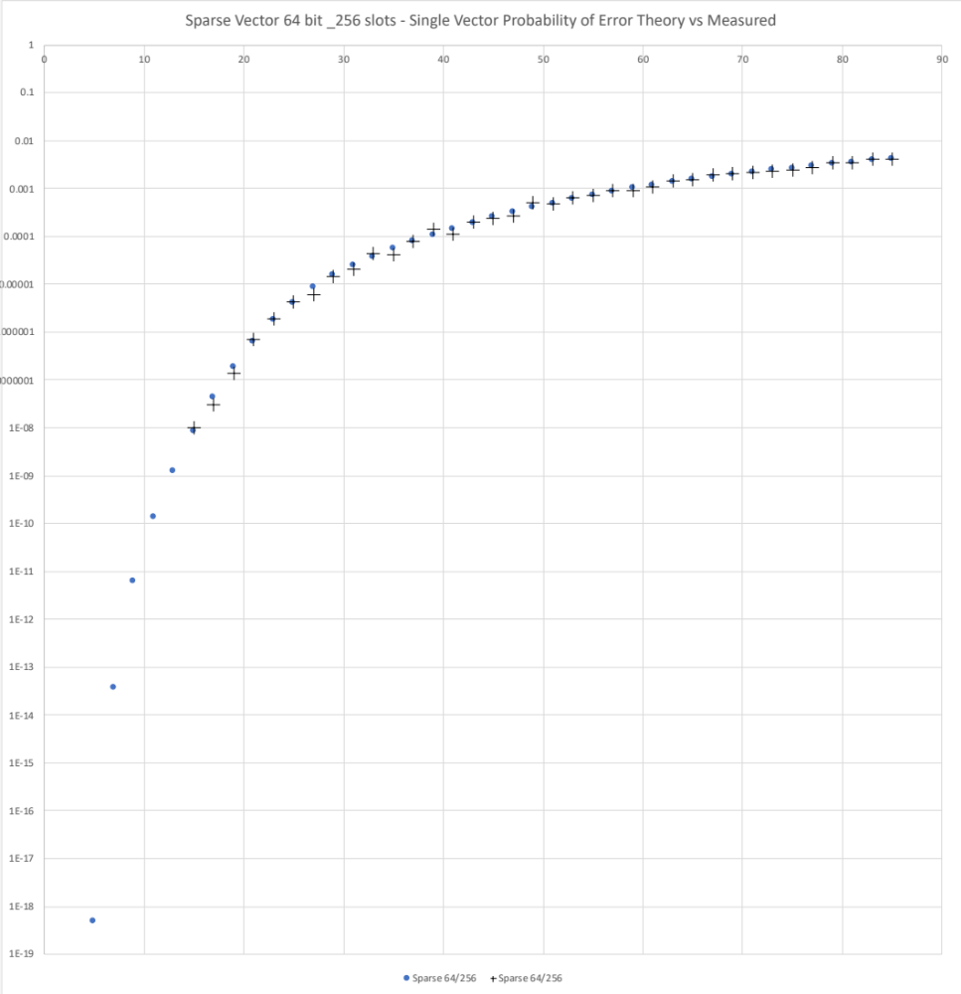
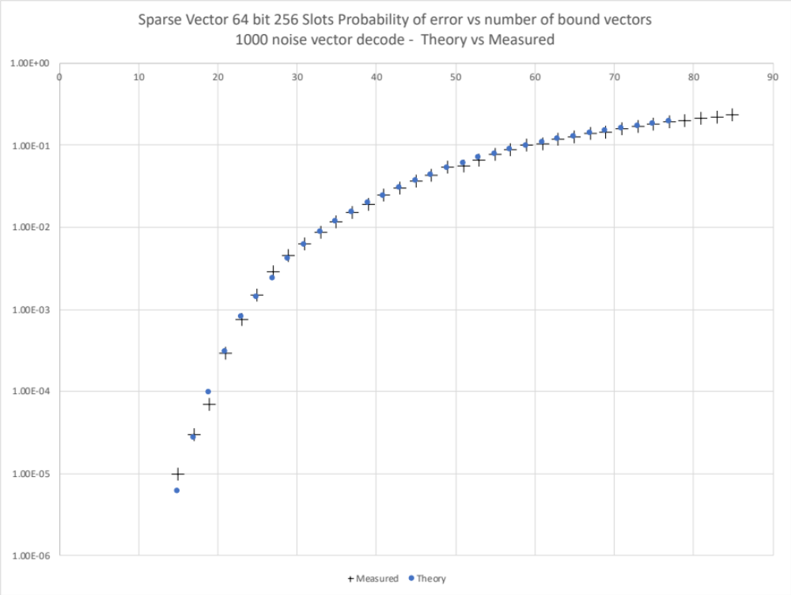

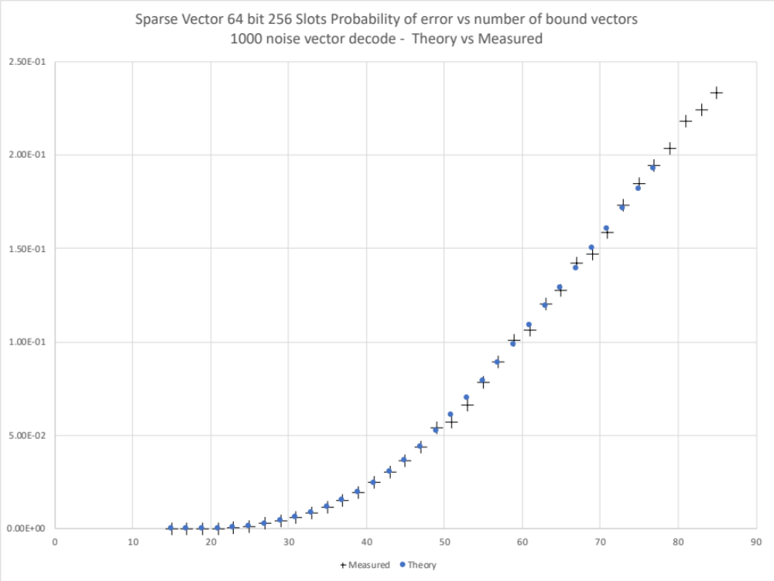
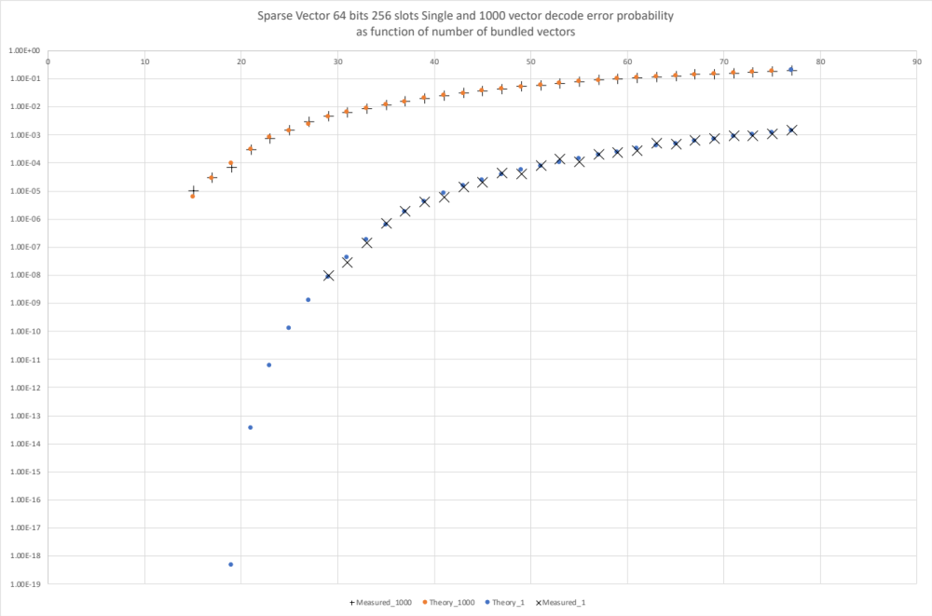

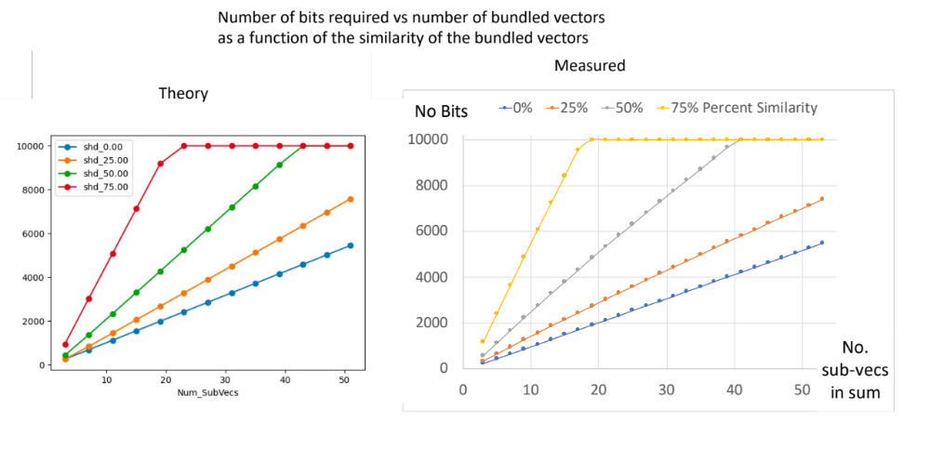

SNN Representation

Charging membrane potential

$$V\left(t\right)= V_{0} ℮^{mt} 0≤t≤t_{1}$$

$$V\left(t\right)= V\left(t_{1}\right) t_{1}≤t ≤t_{2}$$

Discharging membrane potential

$$V\left(t\right)= V_{0} ℮^{-mt} t>t_{2}$$

Where

$$m= \frac{-ln\left(\frac{V_{t}}{V_{0}}\right)}{Δt}$$

